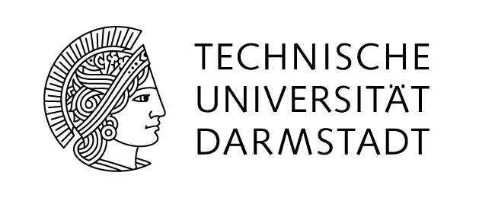
Application
Additional forms for Student Exchange

Dear colleague,
Please send us this form together with a print-out of the student’s online application either by mail or as one soft copy by email.
Thank you

Letter of Nomination

I herewith confirm the nomination of the following student:

Student’s full name:

Home Institution:

Name of Exchange Coordinator:

____________________ ______________________________________________
Date: day/month/year Original Signature and Stamp of Exchange Coordinator

Student Visa Information

Student’s full name:
As a student with a passport from the USA, Canada, Australia or New Zealand you can enter Germany without a visa. In the case you plan to study and live in Germany and/or in the European Shengen area for longer than 90 days, you are required to apply for a Student Visa within 12 weeks after your arrival in Germany.
But, to ease your start in Darmstadt, we recommend you to already take care of the visa from your home country. Please consult with your local embassy or consulate general.

If you are not a citizen of one of the above mentioned countries, please make sure to check the visa regulations for your country before travelling to Germany.

If you apply for a Student Visa after your arrival in Germany you must submit a formal application and the following documents to the authorities in Germany:

1. Your matriculation papers proving you are a registered student at TU Darmstadt and /or are taking the
Intensive German Language Course
2. Lease contract of apartment/room in Germany
3. Proof of German health insurance
4. A valid passport and a photocopy of the picture page
5. 2 passport photos (to be taken in Germany because of picture format, 35 x 45 mm)
6. Proof of financial means: By German law, in order to apply for a Student Visa, international students must prove they have € 720 per month for the entire period of their intended studies in Germany.

Proof of Financial Means
There are two (three) ways of delivering the “Proof of Financial Means”:

1) Open a “limited-access savings account” or “blocked-account” at a German bank
The required amount of money (depending on the length of your studies in Germany) is deposited in a “restricted-access savings account” at a German bank of your choice. You can only withdraw € 720,- per month, thereby ensuring that you have sufficient funds until the end of your studies in Germany. The Immigration office in Darmstadt will provide you with the necessary paperwork to open this special account.

2) A scholarship letter from TU Darmstadt, the Fulbright Commission or DAAD.
The scholarship letter must be written in German and issued by a non-profit organization based in Germany or an institution of higher education. If the monthly scholarship does not meet the € 720, - requirement, you can combine the scholarship funding with a limited-access savings account in which the missing amount is deposited.

3) Formal obligation letter issued by a German embassy or consulate general
(not recommended for US and Canada)

I have thoroughly read and understood the requirements for student visa application and the methods of delivering proof of financial means:

______________________________ _____________________________________
Date: day/month/year Student's signature

Learning Agreement

Please do not forget to include the Learning Agreement, for which a separate form is provided.

